SIMATS ENGINEERING
Assignment
COURSE NAME: OBJECT ORIENTED ANALYSIS AND DESIGN
COURSE CODE: CSA11

COURSE OUTCOME COVERED
CO1: Analyse the fundamentals of Object-Oriented Systems Development, including object basics, Object-Oriented Systems Development Life Cycle, Object-Oriented Methodologies, Model-Driven Development (MDD), and Agile practices.
CO2: Apply UML techniques including Use Case, Class, Interaction, State Transition, Activity, Package, Component, and Deployment Diagrams to model a software system.
CO3: Analyse objects, classes, attributes, methods, and relationships through Use Case Modelling, Object Analysis, Classification, and identification of object relationships.

Assignment Weightage: 100%

QUESTIONS: 1 Total Marks:100
Annexure A
Assignment

Code of Conduct:

I _____________DHARSHITA V /192521096_______ (Name / Reg No) certify that this submission is my original work and that I have adhered to the guidelines specified for this assessment.
I understand that any violation of academic integrity rules will result in disciplinary action.

Signature of the student:

Course Code & Name
CSA11 – Object Oriented Analysis and Design
Assignment Title | Object-Oriented Analysis and UML-Based Design of an Intelligent Food Waste Reduction and Redistribution System (IFWRRS)
Course Outcome(s) – CO | CO1: Analyse Object-Oriented Systems Development concepts and methodologies to understand and model a real-world software problem.  CO2: Apply UML modelling techniques including Use Case, Class, Interaction, State Transition, Activity, Package, Component, and Deployment Diagrams.  CO3: Analyse objects, classes, attributes, methods, and relationships through Use Case Modelling, Object Analysis, Classification, and relationship identification.
Bloom’s Taxonomy Level | BL3 – Apply, BL4 – Analyse, BL5 – Evaluate, BL6 – Create
SDG Mapping (SDG 1–17) | SDG 2 – Zero Hunger  SDG 11 – Sustainable Cities and Communities  SDG 12 – Responsible Consumption and Production  SDG 13 – Climate Action

Problem Statement
Analyse and develop an Object-Oriented Analysis and Design model for an Intelligent Food Waste Reduction and Redistribution System (IFWRRS) that connects restaurants, hotels, supermarkets, food suppliers, charitable organizations, delivery partners, and administrators to reduce avoidable food waste and facilitate timely redistribution of surplus food.
The system shall allow registered food providers to record surplus food, specify quantity, type, preparation time, expiry period, storage requirements, and pickup location. The system shall identify suitable recipient organizations based on food requirements, location, quantity, urgency, and availability.
Recipient organizations shall be able to view available food donations, request suitable items, confirm collection, and update distribution status. Delivery partners shall receive pickup and delivery assignments and update the transportation status. Administrators shall monitor food donations, organizations, deliveries, users, and system reports.
The system shall generate notifications when surplus food is approaching its expiry period and support intelligent matching between food providers and recipient organizations. Working from this scenario, students shall identify actors, objects, classes, attributes, methods, and relationships and develop Use Case, Class, Sequence, Activity, State Transition, Package, Component, and Deployment Diagrams.
Students shall analyse object responsibilities and apply suitable design principles and design patterns to achieve high cohesion, low coupling, reusability, maintainability, and scalability.

Constraints
The design shall clearly distinguish different stakeholders and their responsibilities. All identified classes, attributes, operations, and relationships shall be traceable to the identified use cases.
The system shall consider food expiry, notification timing, matching criteria, delivery status, user roles, data consistency, and transaction management. UML diagrams shall be mutually consistent and shall accurately represent the proposed system behaviour.
The final submission shall include assumptions, constraints, object responsibility analysis, design-pattern justification, and traceability between requirements, use cases, and design elements.

Tools Can Be Used
- StarUML
- Visual Paradigm
- Draw.io
- PlantUML
- Papyrus Tools
- ArgoUML
- Enterprise Architect
- Lucidchart

Assessment Rubrics
Criteria (CO Mapping) | Max Marks | Excellent | Good | Satisfactory | Needs Improvement
Problem Understanding, Object Identification & Requirements Analysis (CO1) | 10 | Clearly analyses the problem domain and accurately identifies all major actors, objects, system responsibilities, and requirements from the given scenario. | Identifies most actors, objects, and requirements with minor gaps or inaccuracies. | Identifies basic actors and objects but analysis is incomplete or contains some inconsistencies. | Poor understanding of the problem; major actors, objects, and requirements are missing or incorrectly identified.
Use Case Modelling & Actor Identification (CO2) | 10 | Correctly identifies all relevant actors and use cases; Use Case Diagram clearly represents system boundary, relationships, and interactions. | Most actors and use cases are correctly identified with minor modelling errors. | Basic actors and use cases are identified, but relationships or system boundary need improvement. | Actors and use cases are poorly identified; diagram is incomplete or inconsistent.
Class Identification, Attributes, Methods & Relationships (CO2/CO3) | 15 | Classes, attributes, methods, associations, aggregation/composition, inheritance, and dependencies are accurately identified and logically justified. | Class structure is mostly correct with minor errors in attributes, methods, or relationships. | Basic classes and relationships are identified but lack detail or contain several modelling issues. | Classes, attributes, methods, or relationships are missing, inappropriate, or poorly structured.
UML Behavioural & Interaction Modelling (CO2) | 15 | Sequence, Activity, and State Transition Diagrams accurately represent system behaviour and are fully consistent with the identified use cases and classes. | Behavioural diagrams are mostly correct with minor inconsistencies. | Basic behavioural diagrams are provided but some interactions, activities, or states are incomplete. | Behavioural diagrams are missing, unclear, or inconsistent with the proposed system.
UML Architectural Modelling & Design Evaluation (CO3) | 15 | Package, Component, and Deployment Diagrams clearly represent modular structure, system components, dependencies, and deployment environment with strong justification. | Architectural diagrams are mostly correct with minor omissions or modelling errors. | Basic architectural representation is provided but lacks clarity or sufficient justification. | Architectural diagrams are incomplete, inappropriate, or inconsistent with the system design.
Object Responsibilities, Design Principles, Axioms & Patterns (CO3) | 15 | Responsibilities are appropriately assigned; design axioms, cohesion, coupling, encapsulation, abstraction, and suitable design patterns are clearly justified and effectively applied. | Design principles and patterns are appropriately applied with minor limitations in justification. | Some design principles are identified, but application or justification is limited. | Design principles, axioms, responsibilities, or patterns are absent or incorrectly applied.
Consistency, Traceability & Overall Design Quality (CO3) | 10 | All UML models are mutually consistent, requirements are traceable to use cases/classes, and the overall design is complete, feasible, scalable, and maintainable. | Design is largely consistent and traceable with minor gaps. | Some consistency and traceability are demonstrated, but important links are missing. | Major inconsistencies exist between requirements, use cases, classes, and UML diagrams.
Reflection, SDG Relevance & Learning Outcomes | 10 | Provides insightful reflection on design decisions, challenges, OOAD concepts learned, and clearly establishes the relevance of the selected SDGs. | Provides good reflection with reasonable connection to design decisions and SDGs. | Reflection is present but generic with limited discussion of learning and SDG relevance. | Reflection is missing, superficial, or unrelated to the assignment and SDGs.
Total | 100

Deliverables
To receive full credit, each submission must include the following:
- Problem Analysis and Requirement Summary
- Actor Identification
- Use Case Descriptions
- Use Case Diagram
- Object and Class Identification
- Class Diagram
- Sequence/Interaction Diagram(s)
- Activity Diagram
- State Transition Diagram
- Package Diagram
- Component Diagram
- Deployment Diagram
- Object Responsibility Analysis
- Design Axioms/Principles and Design Pattern Justification
- Assumptions and Constraints
- Requirement-to-Use Case/Class Traceability
- Implementation/Prototype and Results
- Reflection on Design Decisions and Learning Outcomes
- GitHub Upload

1. Introduction
The Intelligent Food Waste Reduction and Redistribution System (IFWRRS) is an object-oriented software solution proposed to reduce avoidable food waste and improve the timely redistribution of surplus food. The assignment scenario identifies food providers such as restaurants, hotels, supermarkets and suppliers, recipient organizations such as charitable institutions, delivery partners and system administrators as the main stakeholders. The system records surplus food, evaluates its suitability for recipients, coordinates collection and delivery, and provides monitoring and notifications.
The purpose of applying Object-Oriented Analysis and Design (OOAD) is to transform the real-world problem into a structured software model. The model identifies actors, objects, classes, attributes, operations and relationships, and then represents static and dynamic behaviour using UML. The design also considers cohesion, coupling, encapsulation, abstraction, scalability and maintainability.

1.1 Objectives
- Reduce avoidable food wastage by making surplus food visible to eligible recipient organizations.
- Support accurate recording of food type, quantity, preparation time, expiry period, storage requirements and pickup location.
- Provide intelligent matching based on food requirements, location, quantity, urgency and availability.
- Coordinate collection and delivery assignments and maintain delivery status.
- Notify stakeholders when food is approaching expiry or when important status changes occur.
- Provide administrators with monitoring and reporting facilities.

1.2 Scope
The scope covers registration and authentication, surplus-food management, recipient requests, intelligent matching, delivery coordination, notifications, administration, reporting and the UML-based design of the proposed software system. The report focuses on analysis and design rather than claiming a completed production implementation.

2. Problem Analysis and Requirements
The central problem is the gap between available surplus food and organizations that can use it before the food becomes unsuitable. Manual coordination can make it difficult to know what food is available, where it is located, how much is available, when it expires and who can collect it. IFWRRS addresses these issues through a shared information system and rule-based matching process.

2.1 Functional Requirements
ID | Requirement | Description
FR1 | User registration and login | Users shall authenticate and access functions according to their roles.
FR2 | Surplus food entry | Providers shall record food type, quantity, preparation time, expiry period, storage requirements and pickup location.
FR3 | Donation availability | The system shall display suitable available donations to recipient organizations.
FR4 | Intelligent matching | The system shall evaluate recipients using requirements, location, quantity, urgency and availability.
FR5 | Donation request | Recipients shall request suitable food items.
FR6 | Collection confirmation | Recipients/providers shall confirm collection and update distribution status.
FR7 | Delivery assignment | Delivery partners shall receive pickup and delivery assignments.
FR8 | Status tracking | Transportation and donation statuses shall be updated throughout the workflow.
FR9 | Expiry notification | The system shall generate notifications as surplus food approaches expiry.
FR10 | Administration and reports | Administrators shall monitor users, donations, deliveries and reports.

2.2 Non-Functional Requirements
- Usability: interfaces should be understandable for providers, recipients, delivery partners and administrators.
- Reliability: donation and delivery status changes should remain consistent.
- Security: authentication and role-based access should protect stakeholder functions.
- Performance: matching and availability searches should return results within reasonable time.
- Maintainability: modules should have clear responsibilities and limited coupling.
- Scalability: the architecture should support increasing users, donations and delivery assignments.

3. Actor Identification and Use Cases
An actor is an external role that interacts with the IFWRRS system. The assignment requires clear separation of stakeholder responsibilities. The four primary actors are Food Provider, Recipient Organization, Delivery Partner and Administrator. A general User concept may support common authentication behaviour.
Actor | Responsibilities
Food Provider | Register/login, record surplus food, update donation information and provide pickup details.
Recipient Organization | View available donations, request suitable food, confirm collection and update distribution status.
Delivery Partner | Receive pickup/delivery assignments and update transportation status.
Administrator | Monitor users, donations, organizations, deliveries and reports; manage operational oversight.

3.1 Major Use Cases
- Authenticate User
- Record Surplus Food
- View Available Donations
- Request Donation
- Match Food with Recipient
- Assign Delivery
- Confirm Collection
- Update Delivery Status
- Generate Expiry Notification
- Monitor and Generate Reports

3.2 Use Case Modelling Approach
The use cases are derived directly from stakeholder responsibilities. Each use case describes a meaningful system service rather than an individual screen. The relationships in the model show who initiates a service and where system processes such as matching and notification are triggered by donation information.
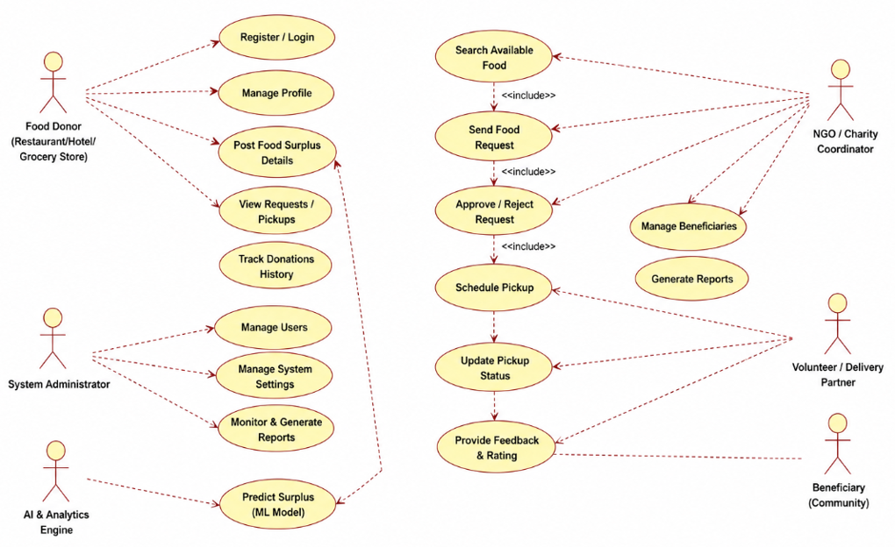
Figure 1. Use Case Diagram – IFWRRS
The diagram places IFWRRS as the system boundary and shows four external actors around it. The Food Provider creates surplus-food records; the Recipient Organization views and requests donations; the Delivery Partner handles assigned transportation; and the Administrator monitors the overall system. Internal services such as matching and expiry notification connect the major workflow steps. This diagram establishes the functional scope before detailed class and interaction design.

4. Use Case Descriptions

UC01 – Authenticate User
Actor: All stakeholders. Precondition: User is registered. Flow: User submits credentials; system validates them; role is identified; authorized functions are shown. Outcome: Authenticated session is created.

UC02 – Record Surplus Food
Actor: Food Provider. Precondition: Provider is authenticated. Flow: Provider enters food type, quantity, preparation time, expiry, storage and pickup details; system validates and saves the donation. Outcome: Donation becomes available for matching.

UC03 – Request Donation
Actor: Recipient Organization. Precondition: Suitable donation is available. Flow: Recipient views details and submits a request; system records the request and updates the donation workflow. Outcome: Request awaits approval/processing.

UC04 – Match Food and Recipient
Actor: System. Precondition: Donation is saved. Flow: Matching service evaluates recipient requirements, location, quantity, urgency and availability; suitable recipients are ranked. Outcome: Candidate recipient list is produced.

UC05 – Assign Delivery
Actor: Delivery Partner / System. Precondition: Donation request is approved. Flow: Pickup and drop locations are assigned to a delivery partner; assignment status is stored. Outcome: Delivery becomes trackable.

UC06 – Confirm Collection and Delivery
Actor: Recipient / Delivery Partner. Precondition: Assignment exists. Flow: Collection and delivery events are recorded; status changes are persisted. Outcome: Donation distribution status is completed.

UC07 – Expiry Notification
Actor: System. Precondition: Donation has an expiry time. Flow: System checks time remaining and sends an alert when configured threshold is reached. Outcome: Stakeholders are informed in time.

UC08 – Monitor Reports
Actor: Administrator. Precondition: Administrator is authenticated. Flow: Admin views donation, delivery, user and status information and generates reports. Outcome: Operational visibility is improved.

5. Object and Class Identification
Object identification converts important nouns and responsibilities in the problem statement into candidate objects. Examples include User, FoodProvider, FoodDonation, RecipientOrganization, DeliveryAssignment, Notification and Administrator. These candidates are then refined into classes based on common attributes, behaviour and relationships.

5.1 Core Classes
Class | Key Attributes | Major Operations
User | userId, name, email, role | login(), logout()
FoodProvider | providerId, organizationName, location | addSurplus(), updateDonation()
FoodDonation | donationId, foodType, quantity, prepTime, expiryTime, storageReq, status | create(), updateStatus()
RecipientOrganization | recipientId, name, requirements, location | requestDonation(), confirmCollection()
DonationMatcher | matchId, score | match(), rankRecipients()
DeliveryAssignment | deliveryId, pickup, dropLocation, status | assign(), updateStatus()
NotificationService | notificationId, message | send(), scheduleExpiryAlert()
Administrator | admin role and monitoring privileges | monitor(), generateReport()

5.2 Attributes and Operations
Attributes represent the information required to describe an object at a particular point in time. Operations represent behaviour that the object or service is responsible for performing. The design keeps data and related behaviour together where appropriate, supporting encapsulation and reducing unnecessary dependencies.

5.3 Relationships
- A User may operate as a Food Provider or Recipient depending on role.
- A Food Provider creates one or more FoodDonation records.
- A FoodDonation is evaluated by the DonationMatcher.
- A RecipientOrganization participates in matching and donation requests.
- A successful matching process can lead to a DeliveryAssignment.
- FoodDonation events can trigger NotificationService.
- Administrator has monitoring dependencies on donation and delivery information.

6. Class Diagram and Explanation
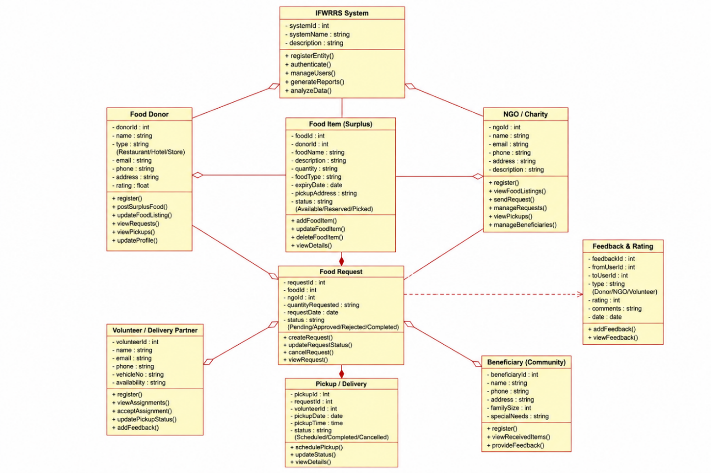
Figure 2. Class Diagram – IFWRRS
The class diagram represents the static structure of IFWRRS. User provides a common identity and role concept, while FoodProvider and RecipientOrganization represent stakeholder-specific responsibilities. FoodDonation is the central business object containing food information and lifecycle status. DonationMatcher evaluates donation suitability and connects providers with recipients. DeliveryAssignment represents transportation work, while NotificationService handles expiry and status notifications. Administrator provides oversight and reporting. The relationships show how responsibilities are connected without placing all logic into a single class.

6.1 Design Interpretation
The FoodDonation class is central because most business events depend on the existence and status of a donation. The DonationMatcher is separated from FoodDonation because matching is a distinct responsibility and may evolve independently. DeliveryAssignment is also separated because transportation has its own status and participants. NotificationService isolates communication logic. This decomposition supports high cohesion and lower coupling.

6.2 Encapsulation
Attributes should be protected through controlled operations rather than allowing unrelated objects to directly modify internal state. For example, updateStatus() can validate permissible status changes before persisting them.

7. Sequence / Interaction Modelling
Sequence modelling explains how objects and services collaborate over time to complete a use case. For IFWRRS, a representative interaction begins when a Food Provider submits surplus-food details and ends with matching, request handling, delivery coordination and notification
The sequence diagram shows the order of messages among the Food Provider, System UI, Donation Service, Matching Service, Recipient Organization, Delivery Service and Notification Service. The provider submits food details to the interface, which passes them to the donation service. The donation service requests matching; the matching service identifies suitable recipients. After a recipient requests the donation, a delivery assignment can be created. Delivery updates are passed to relevant stakeholders, while the donation service schedules expiry alerts. The sequence demonstrates temporal coordination rather than only structural relationships.

7.1 Interaction Benefits
- Clarifies which component initiates each operation.
- Shows the order of validation, storage, matching and delivery steps.
- Helps verify that every important use case has supporting operations.
- Exposes unnecessary dependencies before implementation.

8. Activity Diagram and Explanation
An activity diagram represents the workflow of activities, decisions and alternative paths. In IFWRRS, the workflow starts with authentication, continues through surplus-food entry and validation, and then moves toward matching, recipient request, delivery and notification.
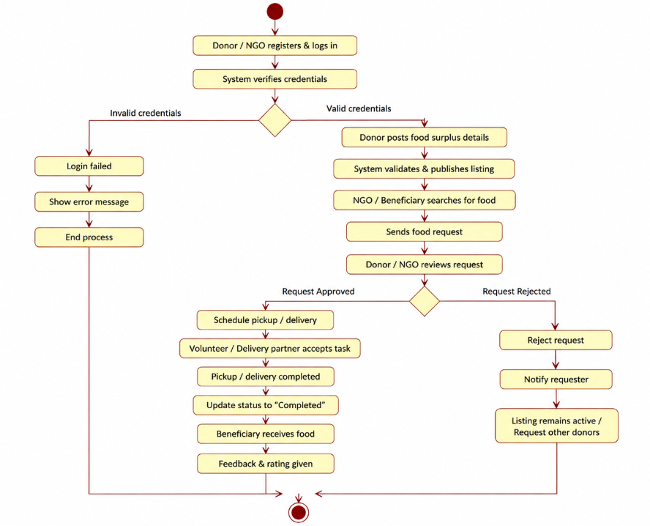
Figure 4. Activity Diagram – Food Redistribution Workflow
The activity diagram begins at Start and moves to Login/Authenticate. The Food Provider then enters surplus-food details. A decision checks whether the information is valid. If it is invalid, the workflow returns to data entry; if valid, the donation is saved. The system finds suitable recipients, a recipient requests the food, and a delivery is assigned. Pickup and delivery take place, status is updated, and notifications are sent before the workflow ends. The decision node is important because it prevents incomplete or invalid donation records from entering the matching process.

8.1 Decision Logic
The validation step should check required fields such as food type, quantity, expiry information and pickup location. Matching should then use the criteria stated in the assignment: requirements, location, quantity, urgency and availability. These checks support reliable system behaviour and reduce unsuitable matches.

9. State Transition Diagram and Explanation
A state diagram models the lifecycle of an important object. In IFWRRS, FoodDonation is an appropriate object because its status changes as the donation moves from creation to availability, matching, request, approval, collection, delivery or expiry.
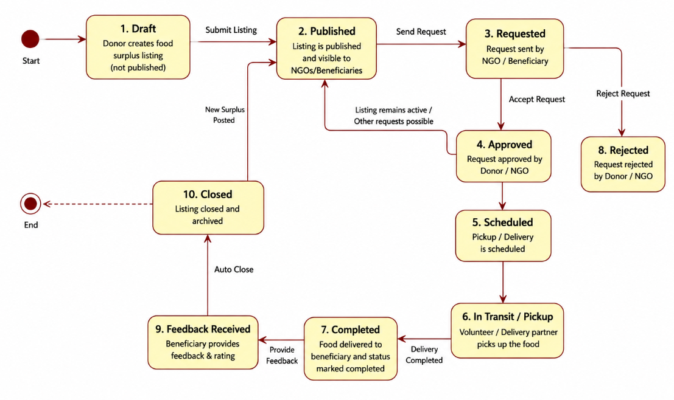
Figure 5. State Transition Diagram – FoodDonation Lifecycle
The state diagram shows Draft, Available, Matched, Requested, Approved, Pickup Assigned, Collected and Delivered as the main successful path. A donation can also reach Expired if its expiry time is reached, or Cancelled when the request or approved process is cancelled. Each transition has a triggering event such as publish, match found, recipient request, approval, assignment, pickup confirmation or delivery confirmation. This diagram helps prevent impossible status combinations and provides a clear lifecycle for implementation.

9.1 State Consistency
The system should enforce valid transitions. For example, a donation should not be marked Delivered before it has a delivery assignment and collection event. Similarly, an Expired donation should not be offered as a fresh available donation. State constraints improve data consistency and operational reliability.

10. Package Diagram and Explanation
Package modelling groups related classes and services into manageable modules. The purpose is to organize the design so that changes in one functional area do not unnecessarily affect unrelated areas.
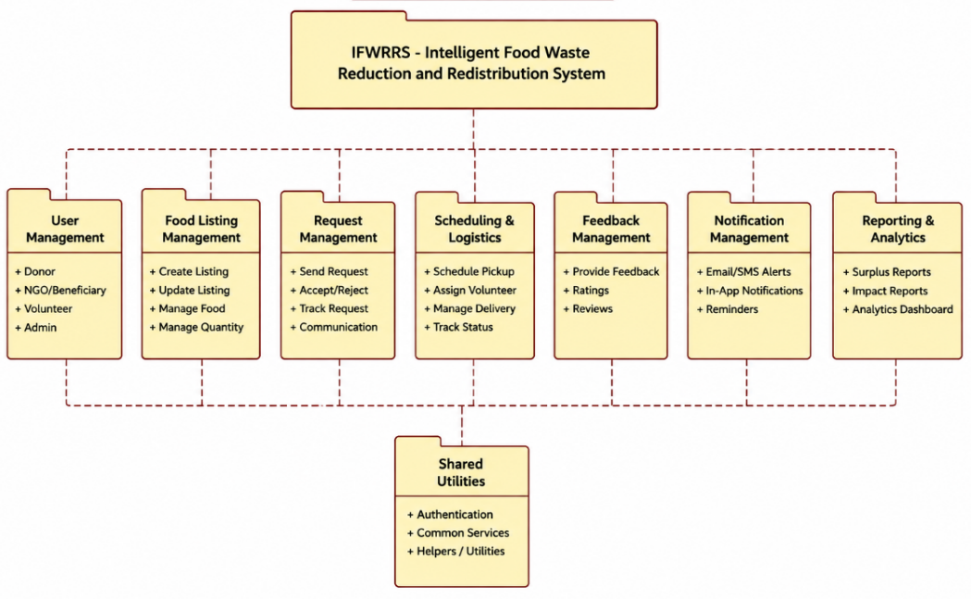
Figure 6. Package Diagram – IFWRRS
The package diagram divides IFWRRS into User Management, Donation Management, Matching Engine, Recipient Management, Delivery Management, Notification and Reporting. User Management supports identity and roles. Donation Management owns surplus-food records. The Matching Engine depends on donation information and recipient requirements. Delivery Management handles assignments and status. Notification responds to donation and delivery events. Reporting reads operational information to produce monitoring views. The dependencies illustrate modular communication while keeping responsibilities separated.

10.1 Modularity
The package structure supports maintainability because each package has a focused purpose. For example, changes to notification delivery mechanisms can be made within Notification without rewriting the core donation model. Reporting can evolve independently as long as its required interfaces remain stable.

11. Component Diagram and Explanation
A component diagram represents the deployable or replaceable software parts and their dependencies. It provides a bridge between logical packages and an implementation architecture.
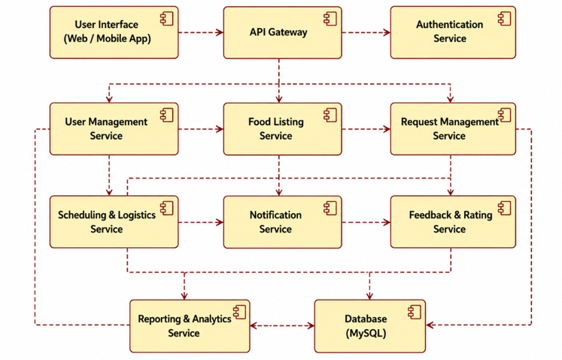
Figure 7. Component Diagram – IFWRRS
The component diagram contains the Web/Mobile UI, Authentication Service, Application API, Matching Engine, Notification Service, Database and Reporting Service. Users access the system through the UI. Authentication protects access, while the Application API coordinates business operations. The Matching Engine performs recipient selection logic. Notification Service handles alerts, and Reporting Service generates operational information. The Database provides persistent storage. The diagram demonstrates that the application is divided into services with clear responsibilities.

11.1 Component Responsibilities
- UI: collects user input and displays system results.
- Authentication Service: validates credentials and role access.
- Application API: exposes business operations and coordinates services.
- Matching Engine: calculates suitability and ranks candidates.
- Notification Service: sends expiry and status alerts.
- Database: stores users, donations, requests, assignments and status information.
- Reporting Service: prepares administrative summaries.

12. Deployment Diagram and Explanation
A deployment diagram maps software components to physical or execution nodes. It helps explain how the proposed system could operate in a real environment.
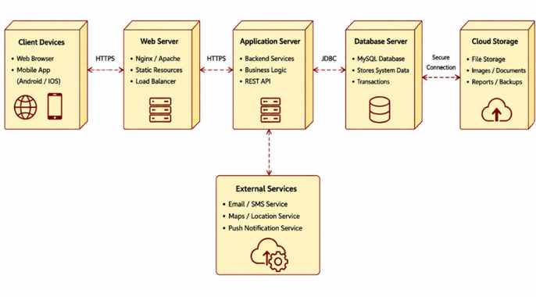
Figure 8. Deployment Diagram – IFWRRS
The deployment diagram shows stakeholder devices such as mobile phones or web browsers connecting through HTTPS to an application server. The application server hosts the API and business logic and communicates with the IFWRRS database for persistent information. It also communicates with a notification gateway for sending alerts. This architecture separates client access, application processing, data storage and external notification services, making the system easier to scale and maintain.

12.1 Deployment Considerations
- Secure communication should be used between clients and the application server.
- Database access should be controlled through the application layer.
- Backups and recovery procedures should protect operational data.
- Application and database resources can be scaled independently when demand grows.
- Notification services should be treated as an external dependency with suitable failure handling.

13. Object Responsibility Analysis
Object Responsibility Analysis assigns each responsibility to the class or service best suited to perform it. The aim is to achieve high cohesion, avoid duplicated logic and minimize unnecessary coupling.
Object / Class | Primary Responsibility | Why It Owns the Responsibility
FoodDonation | Maintain donation details and lifecycle status | It represents the surplus-food business entity.
FoodProvider | Create and update provider-owned donations | It represents the stakeholder supplying food.
RecipientOrganization | Maintain requirements and request food | It represents the receiving organization.
DonationMatcher | Evaluate and rank candidate recipients | Matching is a separate business responsibility requiring multiple criteria.
DeliveryAssignment | Maintain pickup, drop and transport status | Transportation has an independent lifecycle.
NotificationService | Send and schedule alerts | Communication logic should not be embedded in donation or delivery classes.
Administrator | Monitor and generate reports | Administrative oversight is distinct from provider/recipient operations.
Application API | Coordinate cross-module requests | It provides a controlled entry point between UI and domain services.

13.1 GRASP-Style Responsibility Thinking
Information Expert suggests assigning a responsibility to the class that has the information needed to fulfil it. Controller-style coordination is appropriate at the application boundary, while low coupling suggests avoiding direct dependencies between unrelated domain classes. High cohesion is supported by keeping matching, notification and delivery logic in focused components.

14. Design Axioms, Principles and Patterns

14.1 Design Principles
- Encapsulation: internal object state is changed through controlled operations.
- Abstraction: stakeholders interact with meaningful services without needing implementation details.
- High Cohesion: each class or component has a focused purpose.
- Low Coupling: modules communicate through limited, well-defined dependencies.
- Single Responsibility: donation, matching, delivery, notification and reporting responsibilities are separated.
- Reusability: common user and service concepts can support multiple workflows.
- Maintainability: modular architecture allows changes to be isolated.

14.2 Suitable Design Patterns
Pattern | Application in IFWRRS | Justification
Strategy | Alternative matching strategies | Matching criteria can evolve without rewriting the donation model.
Observer / Event Notification | Expiry and status events | Interested notification handlers can react to events without tightly coupling domain objects.
Factory | Creation of notification or assignment objects | Centralizes creation when object construction rules become complex.
Facade | Application API | Provides a simple interface to coordinate several internal services.
Repository | Persistent donation/user access | Separates data access logic from business logic.

14.3 Evaluation
These patterns are design options rather than claims about an implemented codebase. They are justified because IFWRRS contains areas likely to change independently, particularly matching rules, notifications and persistence. Applying patterns only where they reduce complexity is preferable to introducing unnecessary abstraction.

15. Assumptions and Constraints

15.1 Assumptions
- Users are registered and authenticated before performing protected operations.
- Food providers enter accurate food details and expiry information.
- Recipient organizations maintain current requirements and availability information.
- Pickup and delivery locations are sufficiently precise for assignment.
- Delivery partners are available when an assignment is created.
- Administrators have appropriate permissions to monitor operational information.
- The matching engine uses the criteria specified in the assignment scenario.

15.2 Constraints
- Food expiry creates a time-sensitive constraint; late matching can reduce usefulness.
- Data consistency must be maintained when multiple users update a donation or request.
- Role-based access must prevent unauthorized actions.
- Notification delivery may depend on an external communication service.
- The UML diagrams must remain mutually consistent with the requirements and use cases.
- Real-world transportation capacity may limit the feasibility of a theoretical match.

15.3 Risk Mitigation
Risk | Impact | Mitigation
Incorrect expiry information | High | Validate required time fields and display confirmation.
Duplicate requests | Medium | Use controlled request states and transaction checks.
Stale availability | High | Update donation status immediately after approval/collection.
Notification failure | Medium | Log notification attempts and support retry mechanisms.
Unauthorized access | High | Use authentication and role-based authorization.

16. Requirement-to-Use Case/Class Traceability
Traceability demonstrates that the design elements are grounded in requirements. The following matrix connects the major functional requirements with use cases and principal classes.
Requirement | Use Case | Primary Classes / Components
FR1 Authentication | UC01 | User, Authentication Service
FR2 Surplus entry | UC02 | FoodProvider, FoodDonation, Application API
FR3 Donation viewing | UC03 | FoodDonation, RecipientOrganization
FR4 Intelligent matching | UC04 | DonationMatcher, FoodDonation, RecipientOrganization
FR5 Donation request | UC03 | RecipientOrganization, FoodDonation
FR6 Collection confirmation | UC06 | RecipientOrganization, DeliveryAssignment, FoodDonation
FR7 Delivery assignment | UC05 | DeliveryAssignment, Application API
FR8 Status tracking | UC06 | FoodDonation, DeliveryAssignment
FR9 Expiry notification | UC07 | NotificationService, FoodDonation
FR10 Monitoring/reporting | UC08 | Administrator, Reporting Service

16.1 Consistency Check
- Use cases correspond to the actors identified in the problem statement.
- Class responsibilities support the operations required by the use cases.
- Sequence interactions use services/classes present in the class/component models.
- Activity workflow follows the major use-case path.
- State transitions represent the lifecycle of FoodDonation.
- Package, component and deployment diagrams progressively refine the architecture.

16.2 Design Traceability Importance
Traceability helps identify missing functionality and prevents diagrams from becoming isolated drawings. If a requirement has no use case or class responsibility, the design may be incomplete. If a class has no clear requirement or responsibility, it may be unnecessary.

17. Implementation / Prototype and Expected Results
The assignment asks for an implementation or prototype and results. The OOAD model can serve as the blueprint for such a prototype. A practical implementation would provide role-based interfaces for providers, recipients, delivery partners and administrators, backed by persistent donation and delivery data.

17.1 Suggested Prototype Modules
- Authentication and role management.
- Food surplus registration and editing.
- Donation availability and recipient requests.
- Matching and ranking service.
- Delivery assignment and status tracking.
- Expiry and operational notifications.
- Administrative dashboard and reporting.

17.2 Expected Functional Results
Area | Expected Result
Donation capture | Surplus food can be recorded with complete operational details.
Matching | Suitable recipient organizations can be ranked using defined criteria.
Request workflow | Recipient requests move through controlled statuses.
Delivery | Assignments and transportation status are visible to authorized users.
Expiry handling | Approaching-expiry donations generate timely alerts.
Administration | Administrators can review donation, delivery and user information.
Maintainability | Modular design allows individual services to be changed with limited impact.

17.3 Evaluation Approach
A prototype can be evaluated using scenario-based tests: create a donation, validate its details, match it to a recipient, submit a request, assign delivery, confirm collection, update delivery status and verify expiry notification behaviour. Negative tests should cover invalid details, unauthorized access, duplicate requests and invalid state transitions.

18. Reflection, SDG Relevance and Learning Outcomes

18.1 Reflection on Design Decisions
The most important design decision is to treat food redistribution as a coordinated workflow rather than as a simple donation listing. The design separates donation management, matching, delivery, notification and reporting because these responsibilities have different rules and can change independently. UML diagrams helped move from a stakeholder-level problem statement to a detailed object-oriented architecture.

18.2 Learning Outcomes
- Applied object-oriented analysis to identify actors, objects and classes from a real-world scenario.
- Used UML to represent functional requirements, static structure, interactions, workflows, lifecycles and architecture.
- Analysed attributes, operations and relationships and assigned responsibilities to appropriate objects.
- Applied principles such as encapsulation, abstraction, high cohesion and low coupling.
- Evaluated design patterns according to the needs of matching, notification, persistence and service coordination.
- Used traceability to connect requirements, use cases and design elements.

18.3 SDG Relevance
The assignment maps IFWRRS to SDG 2 (Zero Hunger), SDG 11 (Sustainable Cities and Communities), SDG 12 (Responsible Consumption and Production) and SDG 13 (Climate Action). The system's intended reduction of avoidable food waste and redistribution of usable surplus provides a direct conceptual connection to responsible consumption and community support. Better coordination can also contribute to resource efficiency and reduced waste-related environmental impact.

18.4 Future Enhancements
- Real-time location and route optimization.
- Demand forecasting for recipient organizations.
- Data analytics for waste trends and donation performance.
- Mobile notifications and multilingual interfaces.
- Integration with food-safety validation workflows.
- Advanced matching models using historical success data.

19. Conclusion and References to Assignment Basis
The Intelligent Food Waste Reduction and Redistribution System provides a suitable case study for applying Object-Oriented Analysis and Design. The proposed model identifies the stakeholders and their responsibilities, converts the problem into use cases and classes, and then represents system behaviour through sequence, activity and state diagrams. Package, component and deployment diagrams extend the design into a modular architecture. Responsibility analysis, design principles, patterns, assumptions, constraints and traceability complete the design evaluation.
The final design emphasizes maintainability, scalability, low coupling and high cohesion while preserving the core requirement of timely food redistribution. The diagrams are mutually related: the use cases define services, the classes support those services, interaction diagrams show collaboration, the activity diagram shows workflow, the state diagram shows donation lifecycle, and the architectural diagrams organize the software and deployment environment.

19.1 Assignment-Based Source
This report is prepared from the uploaded CSA11 Object-Oriented Analysis and Design assignment brief. The brief specifies the IFWRRS problem scenario, required UML deliverables, constraints, design-principle expectations, SDG mapping and assessment criteria. fileciteturn0file0L26-L65
The assignment deliverables explicitly include problem analysis, actor identification, use cases, Use Case Diagram, Object/Class Identification, Class Diagram, Sequence/Interaction Diagram, Activity Diagram, State Transition Diagram, Package Diagram, Component Diagram, Deployment Diagram, responsibility analysis, design principles/patterns, assumptions/constraints, traceability, implementation/results, reflection and GitHub upload. fileciteturn0file0L381-L400

19.2 Final Summary
IFWRRS demonstrates how OOAD can be used to structure a socially relevant software problem into a consistent UML-based design. The proposed architecture provides a foundation for implementation and future extension while keeping the major stakeholder responsibilities and food redistribution lifecycle explicit.

